
A Guide for Commonly Asked Questions

Information in Connect Reports can be displayed by Units or Dollars, and filtered by *Lending Types (Prime and Alternative, if applicable), Province(s), and Month.
If both Prime and Alternative products are set up in Lender Portal/Velocity, all Lending Types will apply. Newton tracks the Lending Type used by the broker during submission, so it’s important to communicate with brokers to ensure they submit deals through the correct business channels.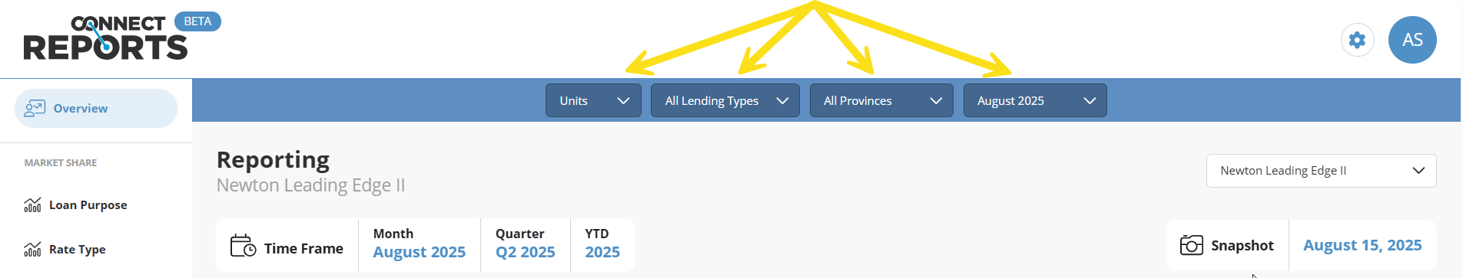
Please keep in mind that when the selected month changes, the corresponding timeframe and data will update accordingly.
Time Frame
Monthly
Provides a month-over-month comparison based on the current snapshot period (either the full month or partial month up to the 15th).
Example:
- August 15 Snapshot: Compares July 1–15 with August 1–15.
- September 1 Snapshot: Compares July 1–31 with August 1–31.
Quarterly
Compares the last two full calendar quarters. Updates occur four times per year, only after each quarter ends.
Example:
- Reviewing Connect Reports in July, August, or September 2025 will show a comparison of Q2 (Apr–Jun 2025) with Q1 (Jan–Mar 2025).
- As of October 1, 2025, the comparison updates to Q3 (Jul–Sep 2025) vs. Q2 (Apr–Jun 2025).
Year-to-Date (YTD)
Compares year-to-date performance with the same period in the prior year.
Example:
- On August 15, 2025, YTD compares Jan 1–Aug 15, 2025 with Jan 1–Aug 15, 2024.
- Selecting July 2025 from the dropdown would adjust the comparison to Jan 1–Jul 31, 2025 vs. Jan 1–Jul 31, 2024.

Submitted, Approved to Funded
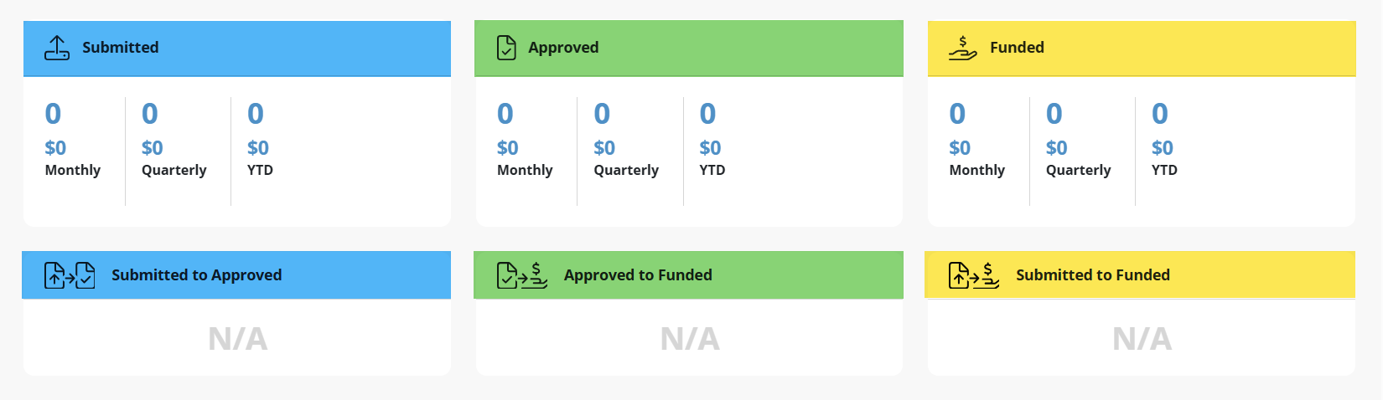

Submitted to Approved
The percentages displayed within each category are based on monthly figures.
They reflect the ratio of Approved deals out of the total number of decisioned deals for the selected month.
Example:
- 100 deals were submitted in September.
  - 10 were not decisioned (e.g., still pending, potential duplicates, or other reasons) these are excluded from the calculation.
  - 54 were Declined.
  - 36 were Approved.
The percentage is calculated as:
36 Approved / 90 Decisioned = 40%
Only deals that have received a decision (Approved or Declined) are included in the ratio
Approved to Funded
FAQ: If N/A is being displayed it may mean that the receiving system is not sending back Accepted responses for our Newton to track.
This percentage reflects the number of deals that were Submitted and ultimately Funded within the selected month.
Only deals that were decisioned (Approved or Declined) are included in the calculation—pending or unreviewed deals are excluded.
Example:
- 100 deals were Submitted with a Funding date in September.
  - 10 were not decisioned (excluded from the calculation).
  - 40 were Approved.
  - 9 of those Approved deals were Funded in September.
The percentage is calculated as:
9 Funded / 90 Decisioned = 10%
This metric provides insight into how many submitted and decisioned deals were successfully funded within the selected timeframe.

Submitted to Funded
This percentage represents the number of Submitted deals that were ultimately Funded within the selected month.
Only deals that have been decisioned (either Approved or Declined) are included in the calculation. Deals that remain undecisioned (e.g., pending, duplicates) are excluded.
Example:
- 100 deals were Submitted with a Funding date in September.
  - 10 were not decisioned → excluded from the calculation.
  - 90 were decisioned.
  - 9 of those decisioned deals were Funded in September.
The percentage is calculated as:
9 Funded / 90 Decisioned = 10%
This metric helps identify the proportion of decisioned deals that were successfully funded in the selected timeframe.

Charts Overview in Connect Reports
Category Charts (Displayed as Percentages)
The following categories are presented as percentage-based charts, broken down using your own data:
- Loan Purpose
- Rate Type
- LTV (Loan-to-Value)
- Term
- Occupancy Status
- Credit Score
You can compare your results against the MARKET or your PEER group by selecting the All Marketplace button on the charts mentioned above.
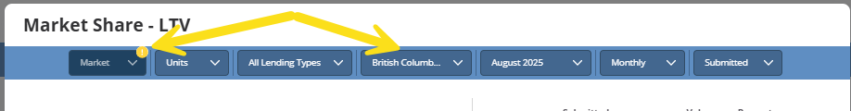
Lenders in your Peer Group may operate in multiple provinces, not just the one selected in your filter. To remove the yellow indicator, set Province filter to All Provinces.

PEER Group Comparison
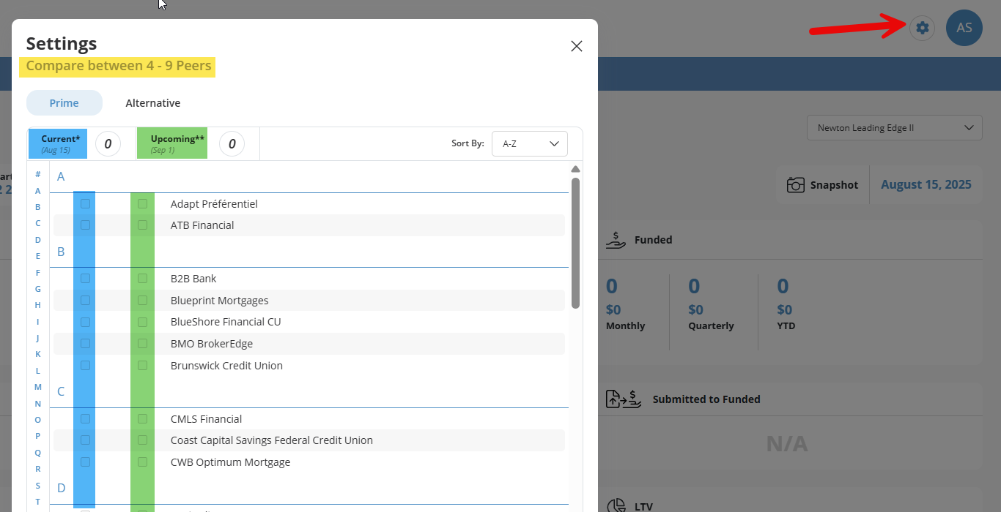
You have the option to create a customized PEER group of competitors:
- Select a minimum of 4 and a maximum of 9 peers.
- You may change your group every 15 days.
- Selections do need to be made in advance. Missed this month? Be sure to make your selection for next.
How to Set Your PEER Group:
- Click the gear icon next to your initials in the top right corner of the screen.
- Tick the boxes beside your selected competitors.
- Repeat for each Lender Type (if applicable).
Peer Grouping Options:
- Current Period (Current):
Displays results for the current 15-day reporting period.
- Upcoming Period (Upcoming):
Sets your peers for the next reporting period and must be selected before the period begins (i.e., before the 15th or last day of the month).

Volume Comparison
Compares your entire year’s performance month over month against another full year, segmented by various application statuses.
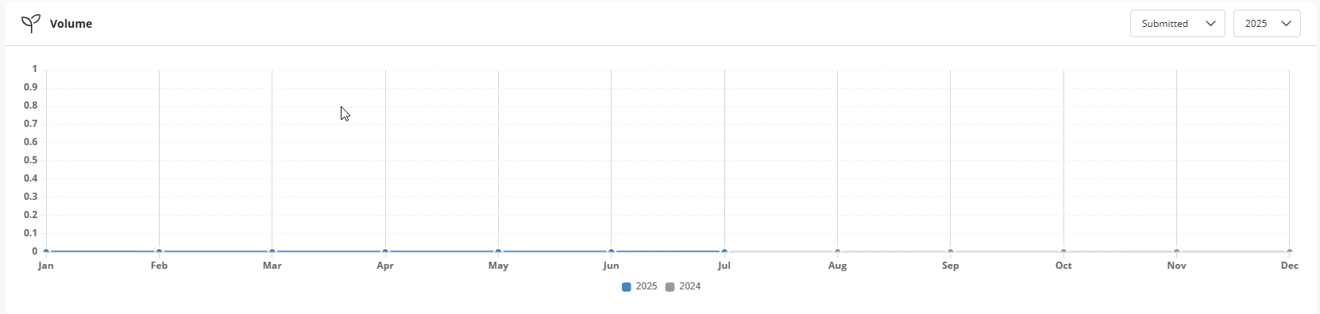
Market Share Rankings
Displays your % of Market Share, ranked:
- Against All Lenders
- And (if applicable) by each Lender Type
You can further filter this data by:
- Market or Peer group
- Month
- Status
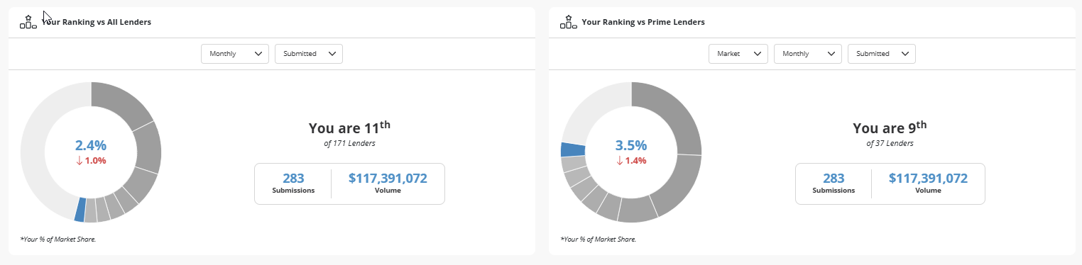


Q: Where is the data in Connect Reports coming from?
A: The insights in Connect Reports are derived from submissions made through Velocity and our integrated Broker POS systems.

Q: Are all submitted applications included in the data?
A: Only live applications are included. Pre-approvals are excluded unless they are resubmitted and converted to an Approval.
Additionally, if an application is submitted to multiple lenders separately, each submission is counted individually. This accounts for approximately 9% of duplicate deals.

Q: Can each Connect Reports account set up their own Peer group?
A: No, only one set of Peer groups (4-9 other lenders) can be selected bi-monthly as a lender. Anyone can set up the Peer groups, so make sure to coordinate with your team!

Q: How accurate are the funding numbers?
A: The funded numbers are regularly updated and dynamically displayed in Connect Reports. They may change based on new information and are compiled using various data sources, including DLCG Central Payroll System.

